**Critique # 2 Merged Round 8 data (34 countries) (2022) Analysis**

**George Washington University**



Were Vincent Ouma

**Critique # 2 Merged Round 8 data (34 countries) (2022) Analysis**

**Introduction**

In this assignment, we embark on a comprehensive exploration of various scenarios using the Afrobarometer dataset, aiming to employ appropriate statistical techniques to glean insights from complex social phenomena. Our journey takes us through three distinct scenarios, each offering unique research questions and challenges. Through careful consideration and analysis, we will assess the suitability of ANOVA investigations for informing these studies, ensuring the methodologies align with the data's characteristics and the research objectives. From investigating political views among different age groups to probing poverty levels across various race groups post-COVID-19 and finally delving into the relationship between presidential candidate characteristics and democracy considerations, this assignment seeks to demonstrate the nuanced application of statistical analysis to real-world social inquiries.

***Scenario A: Investigating Political Views Among Different Age Groups***

*ANOVA investigation is appropriate*

In this scenario, James wants to determine if political views differ among Africans in different age groups using the Afrobarometer dataset. He plans to use a one-way ANOVA analysis. Given that the dependent variable ("Discuss Politics") is ordinal and the independent variable ("Age_V5") is a scale variable, the suggested ANOVA investigation is appropriate. The age groups can be categorized as "Youth (18-30)," "31-45," "46-60," and "Over 60."

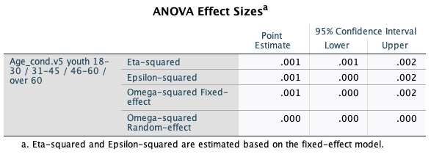

James has conducted assumption checks, checked for normality and homogeneity of variances, determined the minimum sample size, and performed group comparisons using Tukey's test. The effect size was calculated as 0.08. However, the power was calculated as 0, which is not ideal. To ensure reliable results, it's crucial to have adequate statistical power (usually above 0.8) (Tian et al,2018). This discrepancy might be due to various factors, such as the effect size or sample size. James should aim to increase the sample size or make adjustments to the research design to achieve better statistical power.

***Scenario B: Poverty Levels Across Different Race Groups Post-COVID-19***

*ANOVA is not appropriate*

Joyce's team is interested in investigating whether poverty levels differ based on race and COVID-19 considerations. They plan to use a within-subject ANOVA analysis. The independent variable is "Race" (Nominal), and the dependent variable is the "Poverty Index" (Scale). Given the dataset's structure and the research question, a within-subject ANOVA is not appropriate. Within-subject ANOVA is typically used for repeated measures within the same participants, but here the groups (different races) are distinct and unrelated.This could be seen even from the descriptive statistics.  
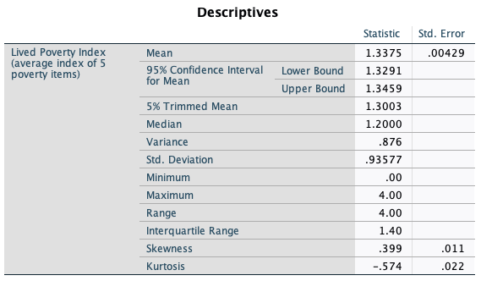

An alternative analysis could involve conducting a one-way ANOVA or non-parametric equivalent, such as the Kruskal-Wallis test, to compare poverty levels among different race groups. This approach would treat the race groups as independent categories and assess whether there are significant differences in the poverty index between the groups.

***Scenario C: Relationship Between Presidential Candidate Characteristics and Democracy Considerations***

*ANOVA analysis is not appropriate*

In this scenario, Kai aims to explore the relationship between views related to presidential candidate characteristics and democracy considerations. The variables involved are "Presidential Candidates" and "Democracy Consideration." To assess this relationship, a factorial ANOVA could be a suitable technique.

Given that both "Presidential Candidates" and "Democracy Consideration" are nominal variables, conducting a factorial ANOVA analysis might not be the most appropriate choice. Factorial ANOVA is typically used when you have at least one categorical independent variable and one continuous dependent variable.

For nominal-nominal variable combinations, a more suitable approach is a chi-squared test or a similar non-parametric analysis, depending on the specific nature of the data and research question. The chi-squared test assesses the association between two categorical variables and determines whether the observed frequencies significantly differ from the expected frequencies under the assumption of independence. To analyze the relationship between "Presidential Candidates" and "Democracy Consideration," a chi-squared test is performed. This test will provide a measure of association (e.g., Pearson's chi-squared statistic) and a p-value indicating whether there is a statistically significant association between the two variables.

***Hypotheses***

1. Null Hypothesis (H0): There is no association between presidential candidates and democracy considerations.
2. Alternative Hypothesis (Ha): There is an association between presidential candidates and democracy considerations.

***Chi-Squared Test***

The calculated chi-squared statistic is 22.6 and the associated p-value is 0.001 . With a significance level of 0.05, since 0.001 < 0.05, we reject the null hypothesis.

***Interpretation***

There is a statistically significant association between presidential candidates and democracy considerations (χ² = 22.6, p < 0.05). This indicates that the preference for presidential candidates is not independent of respondents' level of democracy consideration. In sum, there is evidence to suggest that the distribution of preferences for presidential candidates differs significantly across different levels of democracy consideration.

**Conclusion**

In this comprehensive analysis journey, we've navigated through three diverse scenarios, each presenting its own intricacies and challenges. Through rigorous examination, we've determined the appropriateness of ANOVA investigations for informing these studies. While ANOVA proved suitable for investigating political views across age groups, it was deemed less fitting for assessing poverty levels across race groups post-COVID-19, leading us to propose alternative approaches. In the case of the relationship between presidential candidate characteristics and democracy considerations, we highlighted the importance of matching analysis techniques to the measurement levels of variables. These scenarios have illuminated the crucial role of methodological alignment, providing valuable insights into the intricate art of statistical analysis in social research.

**References**

Tian, C. H. E. N., Manfei, X. U., Justin, T. U., Hongyue, W. A. N. G., & Xiaohui, N. I. U. (2018). Relationship between Omnibus and Post-hoc Tests: An Investigation of performance of the F test in ANOVA. *Shanghai archives of psychiatry*, *30*(1), 60.

Sawilowsky, S. S., Blair, R. C., & Higgins, J. J. (1989). An investigation of the Type I error and power properties of the rank transform procedure in factorial ANOVA. *Journal of Educational Statistics*, *14*(3), 255-267.

Bademlioglu, A. H., Canbolat, A. S., Yamankaradeniz, N., & Kaynakli, O. (2018). Investigation of parameters affecting Organic Rankine Cycle efficiency by using Taguchi and ANOVA methods. *Applied Thermal Engineering*, *145*, 221-228.

Ginot, V., Gaba, S., Beaudouin, R., Aries, F., & Monod, H. (2006). Combined use of local and ANOVA-based global sensitivity analyses for the investigation of a stochastic dynamic model: application to the case study of an individual-based model of a fish population. *Ecological modelling*, *193*(3-4), 479-491.